SwitchVI 48 Summary 20 September 2005

We collected 49 subs (subject nr 37 accidentally duplicated) in 6 groups (~ 8 in each). This is ellipses experiment when color of the ellipse can be black or white determining key switch/different category.

To remind:
There were 2 category structures (CJ and II) and 3 conditions:
2catCont - color is irrelevant, there are two categories
2catSwitch - color is relevant, there are 2 categories, black ellipses has exactly opposite category than white ellipses
4cat - color is relevant, there are 4 categories, black ellipses have different cat names than white ellipses

Accuracy analyses:

Summary: 4categories are easy for CJ but difficult for II.
This is oposite from what would be expected from 2 OR 4 CAT experiment done in our lab and published earlier.

One-way anova shows significant differences among groups (all blocks, also RT).
3-way mixed anova (5 block x 2 cat str x 3 condition):
Sig:
Block p<.001
Condition p=.001 (switch is difficult)
Block*condition p=.001
Block*catStr p=.044 (learning in CJ, little learning in II)
NS:
CatStr p=.447
Condition*catStr p=.355

Condition*CatStr is NS, but interesting (first chart overall acc, second last block):
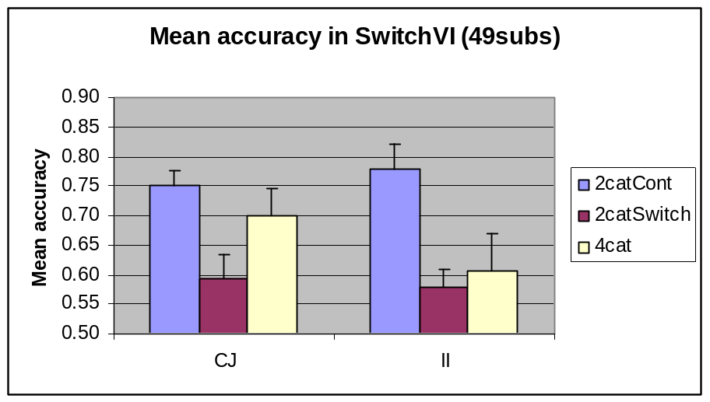
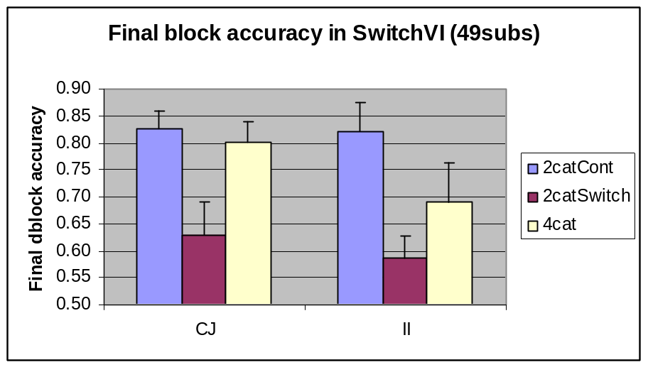

The difference is that for CJ, 4cat=control, both are better than switch. For II, control is better than both switch and 4cat, latter two equal at the beginning, 4cat getting better with training.

Details under the line, may be skipped:

Since ANOVA did not show the CatStr * Condition interaction, I looked at two things that may show the effect in a different way:

1. Effect of condition for each cat str separately:

One-way ANOVA significant or marginal in all cases.
CJ
Post-hoc for overall accuracy shows control > switch.
Post-hoc for last block shows control=4cat > switch.
II
Post-hoc for overall shows control > swich=4cat.
Post-hoc for last block shows control > switch.

T-tests:
CJ
Control > switch (all blocks)
Control = 4cat (except block1 p=.073)
4cat > switch (block3 and 5, overall p=.1 since block1 p=.7)

II
Control > Switch (all blocks)
Control > 4cat (block1 & overall, marginal block3)
4cat = switch (except block 1 p=.053 switch>4cat understandably)

2. Effect of category structure for each condition separately
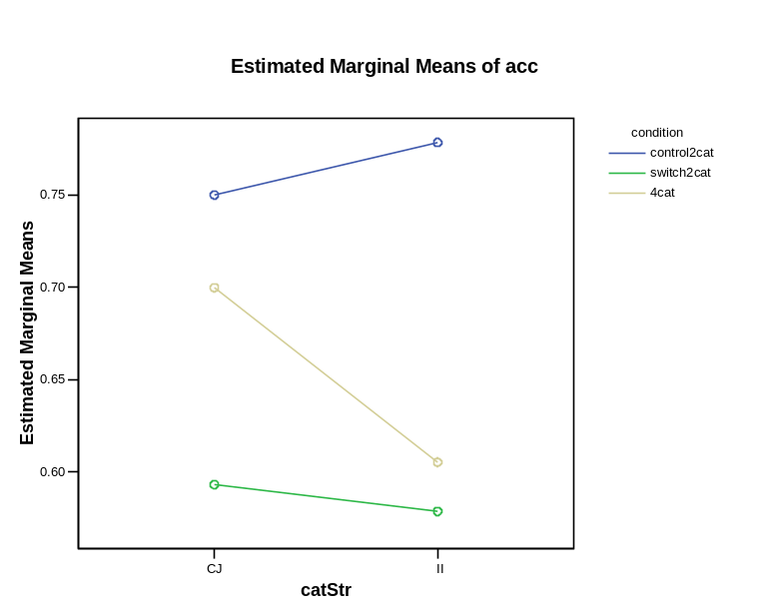
T-tests:

Control: CJ=II (p>.5)
Switch: CJ=II (p>.7)
4cat: NS, but tendency for CJ>II (p=.25)

This is playing with data: Confusion of white and black ellipses – tendency to categorize one color better than another.

To explore the qualitative differences in performance, I created a “preference” measure. It is the aboslute value of the difference between overall performance and perfomance on one color of ellipses. Can be also understood as partitioning of knowledge in case of the control group. Results are interesting but NS.
